Question 1 – Amounts (Bar Chart)
Scenario
A supermarket chain wants to compare the monthly sales revenue generated by different
product categories during June 2026. The management wants to identify the best and worst
performing categories using an appropriate visualization.
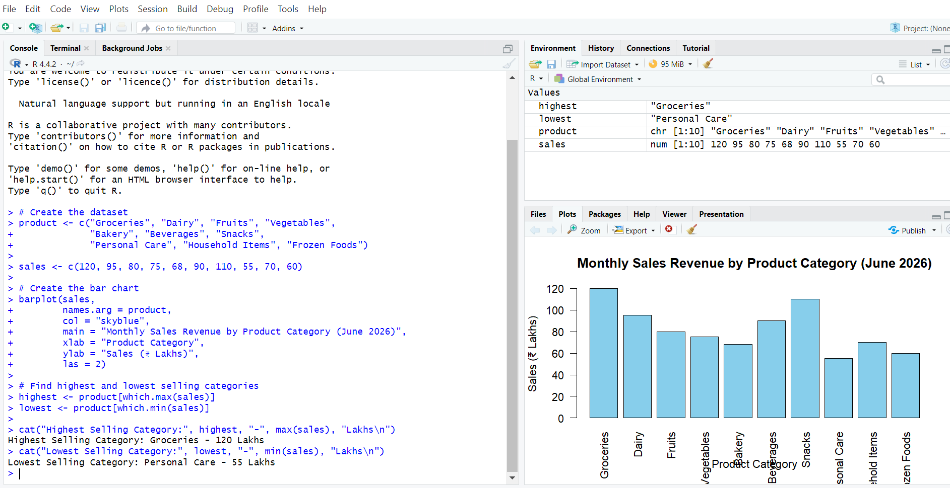

Question 2 – Distribution (Histogram)
Scenario
A university placement cell collected the annual salary packages (in LPA) offered to students
during the campus recruitment drive. The placement officer wants to study the distribution
of salary packages.
Question
Construct a Histogram using the above data. Analyze the distribution of salary packages and
comment on the spread, frequency, and possible outliers.
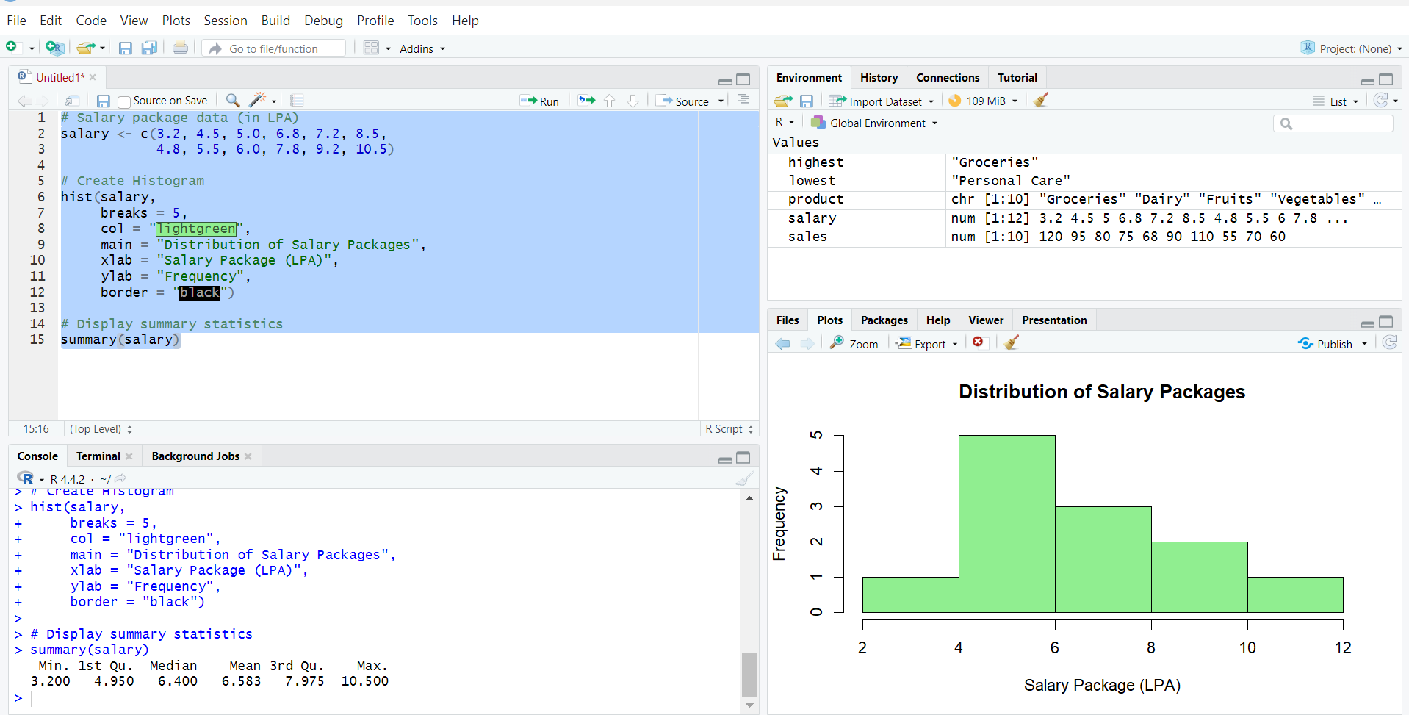

Question 3 – Proportions (Pie Chart)
Scenario
A software company allocated its annual digital marketing budget across different
advertising channels. The marketing manager wants to visualize how the budget is
distributed. Question
Create a Pie Chart representing the marketing budget allocation. Identify the channel with
the highest investment and explain the overall distribution.
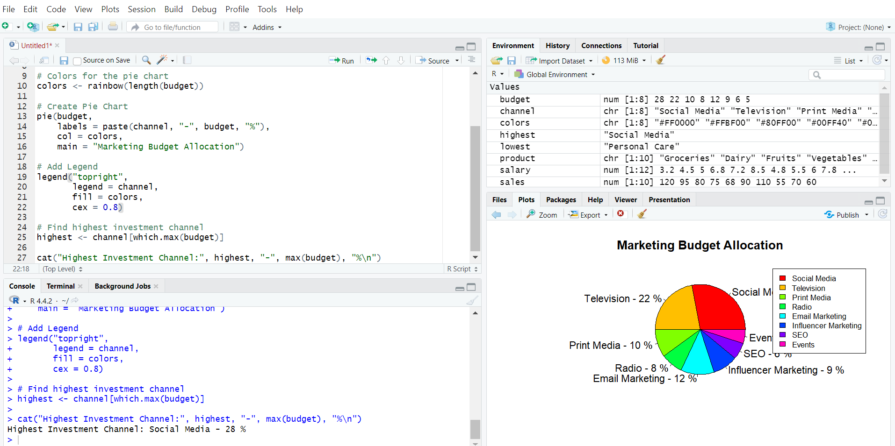

Question 4 – X–Y Relationship (Scatter Plot)
Scenario
An e-commerce company wants to determine whether advertising expenditure influences
monthly sales revenue.
Question
Using the above dataset, create a Scatter Plot to examine the relationship between
advertising expenditure and sales revenue. Determine whether the relationship is positive,
negative, or weak, and justify your answer.
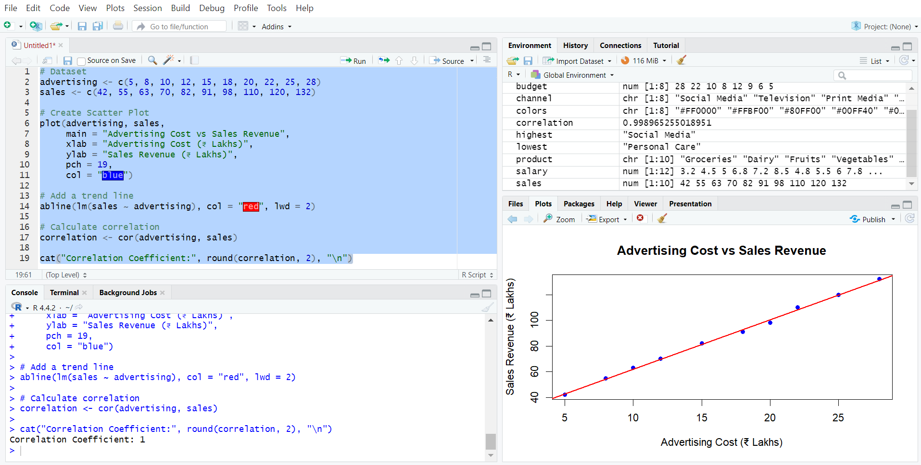

Question 5 – Amounts Over Time (Line Chart)
Scenario
A renewable energy company recorded the monthly electricity generated by its solar power
plant throughout the year 2025. The company wants to study the trend in electricity
generation.
Question
Construct a Line Chart using the above data. Analyze the monthly trend in electricity
generation and identify the months with the highest and lowest energy production. Also
comment on any seasonal variations observed in the data.
